Frame Advantage

Short Pitch

Frame advantage is a website designed for looking up frame data of fighting game characters in an clear format, and made easy for players to study the numbers behind each move.

Long Pitch

Recall is a specialized fighting game data retrieval site where users can look up certain fighting game characters, and bring up information about each of the character’s moves. Such information could include frame data, showing active frames, start up frames, and recovery frames. The data will also include how much damage the move does, as well as hit properties.

Personas

1. Jacob, age 19, male, collegiate level Street Fighter 5 player. He has a passion for Fighting games, and is a Grandmaster ranked player, and was able to join his college’s SFV collegiate team.
2. Ryan, age 26, male, assistant coach for JAS, a team currently sponsoring many professional fighting game players. He is there to help the players figure out which match ups are good, and which are bad, as well as sometimes serve as a practice partner for sparring in game.
3. Daniel, age 15, male, casual Granblue Fantasy: Versus player. Although he isn’t very good at the game, Daniel is very competitive, and very much wants to improve himself through analysis of his mistakes.

Comparative sites

ultimateframedata.com kuroganehammer.com dustloop.com

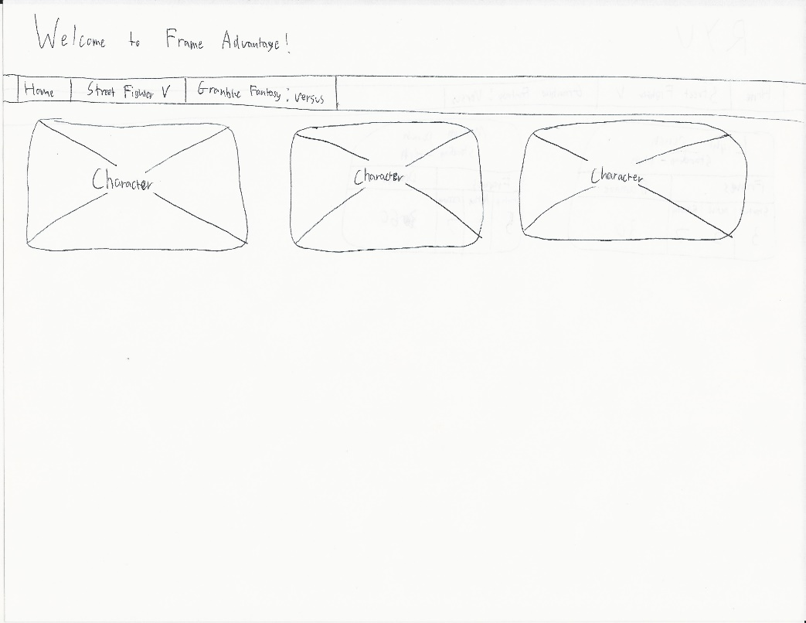

Wireframe of the front page, users will be able to select individual characters, or select a specific game to narrow down which character they are looking for.

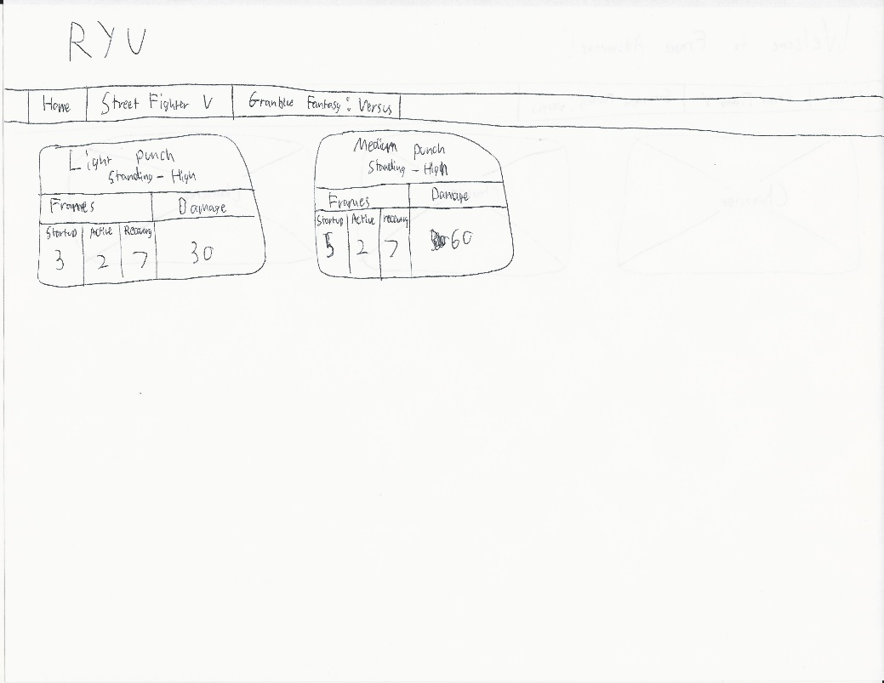

Wireframe of a character that the user selects. From here, they will be able to see certain moves, as well as the frame data and damage that the move does in grid boxes.

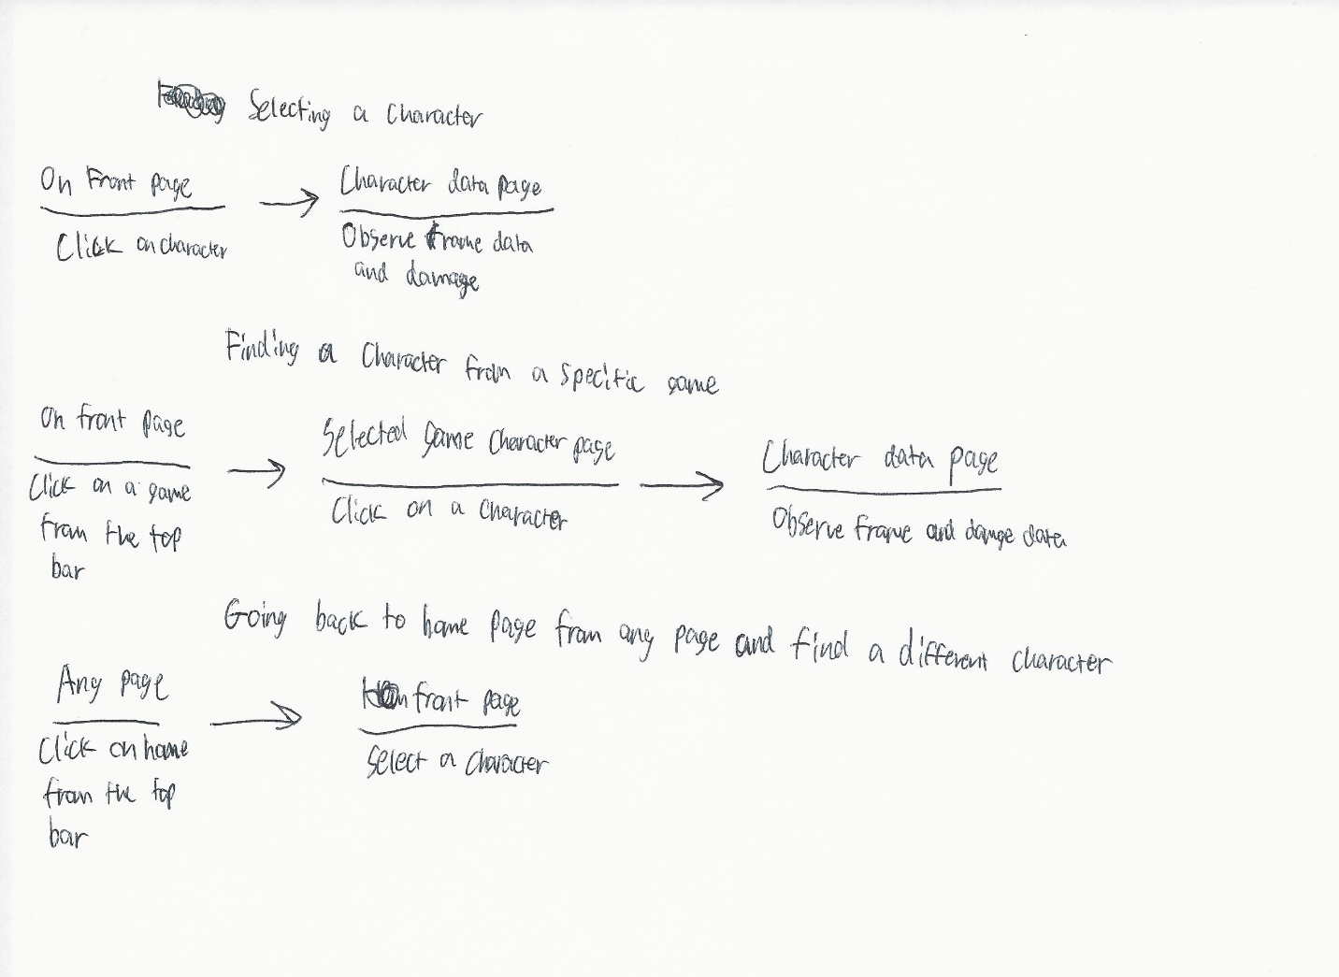

Example user flows that may be common on the website. Includes how a user would navigate to a character page, select a game to narrow down results, or get back to the front page.